Combinations and the Binomial Theorem Test | Name:
K/U |  | T/I |  | C |  | A

Knowledge and Understanding
Short Answer
1. In how many ways can 5 men and 4 women be chosen from a group of 11 men and 12 women?
- $\left({n \atop k}\right)= \frac{n!}{k!\left(n-k\right)!}$
We are choosing 5 men from 11 men
$$\left({11 \atop 5}\right)= \frac{11!}{5!6!}=\frac{11×10×9×8×7}{5×4×3×2×1}=462$$
We are choosing 4 women from 12 women
$$\left({12 \atop 4}\right)=\frac{12!}{4!8!}=\frac{12×11×10×9}{4×3×2×1}=495$$
Therefore, $\left({11 \atop 5}\right)\left({12 \atop 4}\right)=462 ×495=228,690$
- How many 6-card hands from a standard deck of 52 cards would contain two different pairs (but not 3)?
$$\left({n \atop k}\right)= \frac{n!}{k!\left(n-k\right)!}$$

We are excluding 4 3’s in 52 cards
$$52-4=48$$
$$\left({48 \atop 6}\right)= \frac{48!}{6!42!}=\frac{48×47×46×45×44×43}{6×5×4×3×2×1}=12,271,512$$

3. Expand and simplify the expression (5x – 3y²)³ using the binomial theorem.
$${(a+b)}^{n}= \sum_{k=0}^{n}{\left({n \atop k}\right) a^{n-k}b^{k}}$$
$$\left({n \atop k}\right)= \frac{n!}{k!\left(n-k\right)!}$$
$${(5x-3y^{2})}^{3}= \sum_{k=0}^{3}{\left({3 \atop k}\right) {(5x)}^{3-k}{({-3y}^{2})}^{k}}$$
$$\left({3 \atop 0}\right) {(5x)}^{3-0}{({-3y}^{2})}^{0}+\left({3 \atop 1}\right) {(5x)}^{3-1}{({-3y}^{2})}^{1 }+\left({3 \atop 2}\right) {(5x)}^{3-2}{({-3y}^{2})}^{2}+ \left({3 \atop 3}\right) {(5x)}^{3-3}{({-3y}^{2})}^{3}$$
$$\left({3 \atop 0}\right)= \frac{3!}{0!3!}= \frac{3×2×1}{3×2×1}=1$$
$$\left({3 \atop 1}\right)= \frac{3!}{1!2!}= \frac{3×2×1}{2×1}=3$$
$$\left({3 \atop 2}\right)= \frac{3!}{2!1!}= \frac{3×2×1}{2×1}=3$$
$$\left({3 \atop 3}\right)= \frac{3!}{3!0!}= \frac{3×2×1}{3×2×1}=1$$
Therefore:
$1{(5x)}^{3-0}{({-3y}^{2})}^{0}+3{(5x)}^{3-1}{({-3y}^{2})}^{1 }+3{(5x)}^{3-2}{({-3y}^{2})}^{2}+ 1{(5x)}^{3-3}{({-3y}^{2})}^{3}$
$${125x}^{3}+3{(25x}^{2}){({-3y}^{2})}^{ }+3{\left(5x\right)}^{1}(9y^{4})+ 1(-27y^{6})$$
$${125x}^{3}-2{25x}^{2}{y^{2}}^{ }+135xy^{4}-27y^{6}$$

Application
1. A class of 28 students contains 13 males and 15 females. How many different groups of 6 could be selected if:
a. There must be an equal number of males and females.
$$\left({n \atop k}\right)= \frac{n!}{k!\left(n-k\right)!}$$
$$\left({13 \atop 3}\right)= \frac{13!}{3!10!}= \frac{13×12×11}{3×2×1}=286$$
$$\left({15 \atop 3}\right)= \frac{15!}{3!12!}= \frac{15×14×13}{3×2×1}=455$$
$$\left({13 \atop 3}\right)\left({15 \atop 3}\right)=286 ×455=130,130$$
b. Hillary is part of the group, but Laura is not.
$$\left({n \atop k}\right)= \frac{n!}{k!\left(n-k\right)!}$$

$$\left({27 \atop 6}\right)= \frac{27!}{6!21!}=\frac{27×26×25×24×23×22}{6×5×4×3×2×1}=296,010$$

c. There must be at least two males.
2 males =$\left({13 \atop 2}\right)\left({15 \atop 4}\right)=78 ×1,365=106,470$
3 males = $\left({13 \atop 3}\right)\left({15 \atop 3}\right)=286 ×455=130,130$
4 males = $\left({13 \atop 4}\right)\left({15 \atop 2}\right)=715 ×105=75,075$
5 males = $\left({13 \atop 5}\right)\left({15 \atop 1}\right)=1,287 ×15=19,305$
6 males = $\left({13 \atop 6}\right)\left({15 \atop 0}\right)=1,716 ×1=1,716$
$106,470+130,130+75,075+19,305$+$1,716=332,696$
2. At Saint Andre Bessette there are 739 students. 47 students play basketball, 44 students play volleyball and 52 students play badminton. 12 students who play basketball also play volleyball, 6 students who play volleyball also play badminton and 3 students who play basketball also play badminton.
a. If there are 616 students at the school who are not involved in any of these activities, determine the number of students who participate in all 3.
The number of students involved in this activities is: 739 – 661
= 123
47 students play basketball (12 also play volleyball)
44 students play volleyball (6 play badminton)
52 students play badminton (3 play basketball)
The number of students playing different games is (12 + 6 + 3) = 24
b. Construct a Venn diagram for this situation.
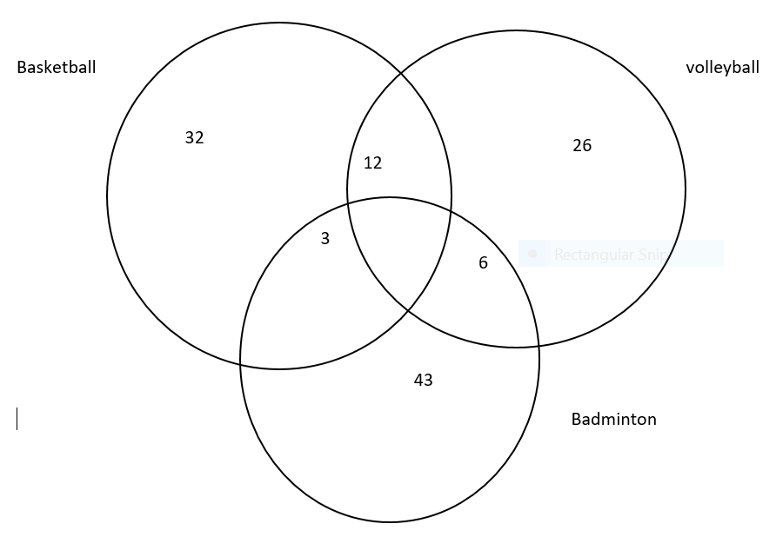
- Mr. Duffy is a high roller. In his wallet he has 7 toonies, 5 loonies and 9 quarters. If he reaches into his wallet and grabs some change, how many different combinations could he choose?
Here we will multiply the number of toonies, loonies and quarters to get the different combinations.
Toonies = 7
Loonies = 5
Quarters = 9
$$7×5×9=315$$
=315 different combinations
Thinking/Inquiry (pick 2)
2. How many 6-card hands from a standard deck of 52 cards would contain two pairs (but not 3)?
$$\left({n \atop k}\right)= \frac{n!}{k!\left(n-k\right)!}$$

We are excluding 4 3’s in 52 cards
$$52-4=48$$
$$\left({48 \atop 6}\right)= \frac{48!}{6!42!}=\frac{48×47×46×45×44×43}{6×5×4×3×2×1}=12,271,512$$

3. Use the Binomial Theorem to simplify the expansion of ${\left(3y^{2 }-\frac{1}{y^{4}}\right)}^{3}$

$${(a+b)}^{n}= \sum_{k=0}^{n}{\left({n \atop k}\right) a^{n-k}b^{k}}$$
$$\left({n \atop k}\right)= \frac{n!}{k!\left(n-k\right)!}$$
$${(3y^{2}-\frac{1}{y^{4}})}^{3}= \sum_{k=0}^{3}{\left({3 \atop k}\right) {(3y^{2})}^{3-k}{(-\frac{1}{y^{4}})}^{k}}$$
$$\left({3 \atop 0}\right) {(3y^{2})}^{3-0}{(\frac{1}{y^{4}})}^{0}+\left({3 \atop 1}\right) {(3y^{2})}^{3-1}{(\frac{1}{y^{4}})}^{1 }+\left({3 \atop 2}\right) {(3y^{2})}^{3-2}{(\frac{1}{y^{4}})}^{2}+ \left({3 \atop 3}\right) {(3y^{2})}^{3-3}{(\frac{1}{y^{4}})}^{3}$$
$$\left({3 \atop 0}\right)= \frac{3!}{0!3!}= \frac{3×2×1}{3×2×1}=1$$
$$\left({3 \atop 1}\right)= \frac{3!}{1!2!}= \frac{3×2×1}{2×1}=3$$
$$\left({3 \atop 2}\right)= \frac{3!}{2!1!}= \frac{3×2×1}{2×1}=3$$
$$\left({3 \atop 3}\right)= \frac{3!}{3!0!}= \frac{3×2×1}{3×2×1}=1$$
$${1(3y^{2})}^{3-0}{(\frac{1}{y^{4}})}^{0}+3{(3y^{2})}^{3-1}{(\frac{1}{y^{4}})}^{1 }+3{(3y^{2})}^{3-2}{(\frac{1}{y^{4}})}^{2}+ 1 {(3y^{2})}^{3-3}{(\frac{1}{y^{4}})}^{3}$$
$=27y^{6}-27+9^{-6}- y^{-12}$

